DIS-HOE-Tennessee-Mississppian

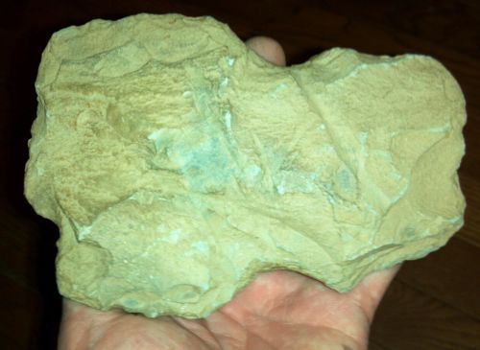

#### [AUTHENTIC NATIVE AMERICAN INDIAN ARTIFACT - ANCIENT TOOL - TENN.](http://www.ebay.com/itm/121758429967)

#### flint ridge material ?

|  |  |  |
| --- | --- | --- |
| Item price | $10.00 |  |
| Quantity | 1 |  |
| Item number | 121758429967 |  |
| Shipping service | USPS First Class Package |  |
| Tellico Plains, Tennessee, United States | | |
| Seller:  [tellicodigger2012](http://www.ebay.com/usr/tellicodigger2012?_trksid=p2047675.l2559) | | |

Found in Polk county TN. Axe is 6" long. Field grade has new and old plow marks .